|  |  |
| --- | --- |
| TITLE | Smart Farmer-IOT Enabled Smart Farming Application |
| DOMAIN NAME | INTERNET OF THINGS |
| TEAM ID | PNT2022TMID12291 |
| LEADER NAME | ADITHYA ARAVIND S |
| TEAM MEMBER NAME | AVINASH M  ABHILASH S  DWARAGAES C |

Step1: Log in your registered id

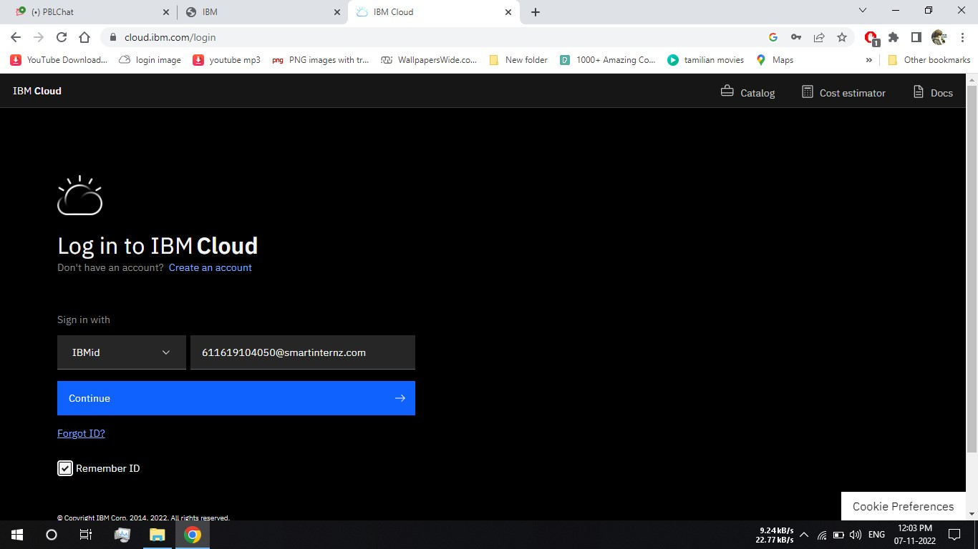

Step 2: click catalog where you find the services and internet of thing you can select and make location as London

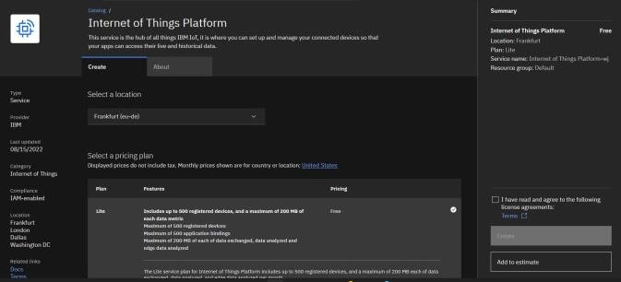

Step 3: click create and the launch tab get open, then click launch

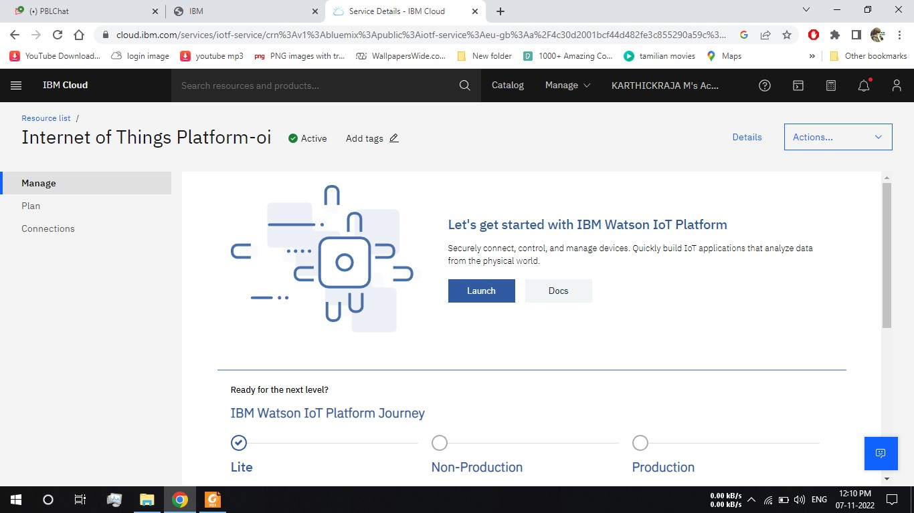

Step 4: It redirect you to IBM WATSON platform where you need to click sign in

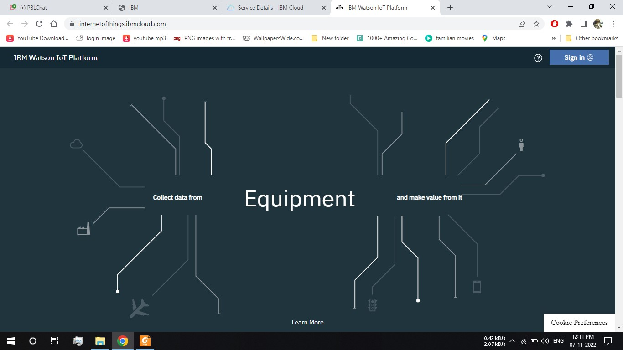

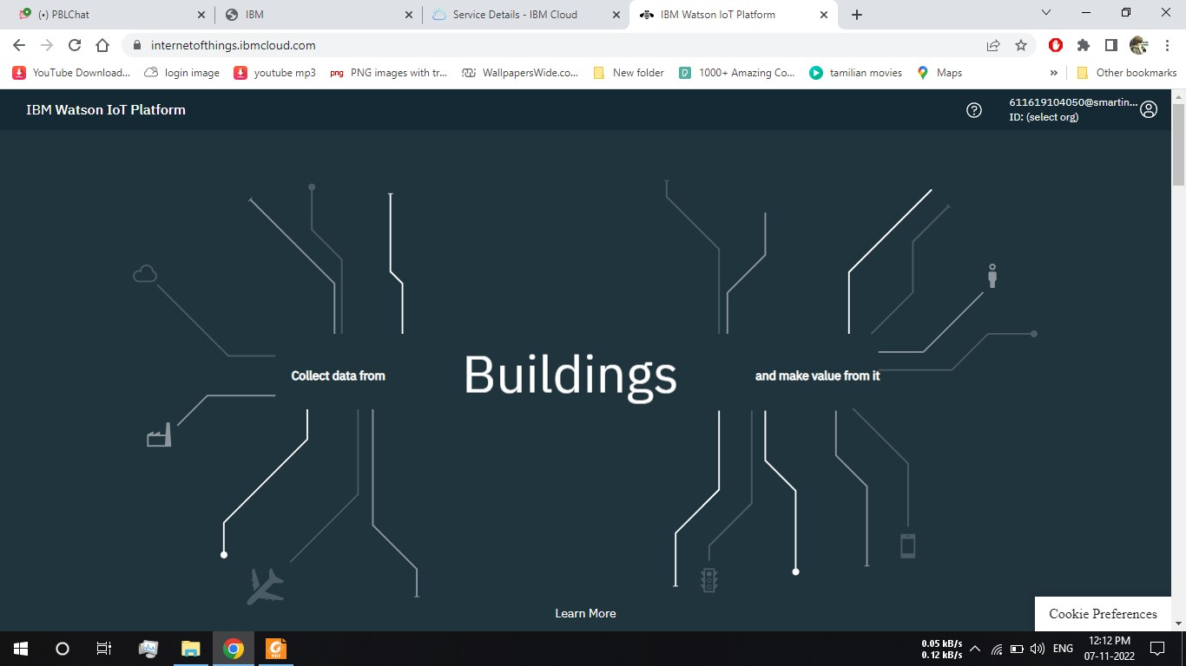

Step 6: where you find this tab which is used to add device, app, member, usage, and security can be worked

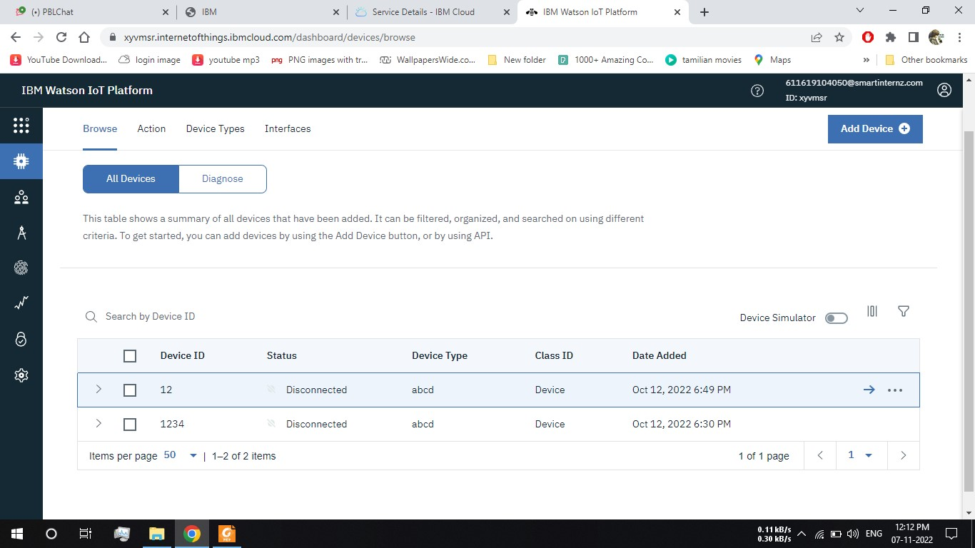

Step 7: check boards for risk and security overview card, it uses for graphical representation boards

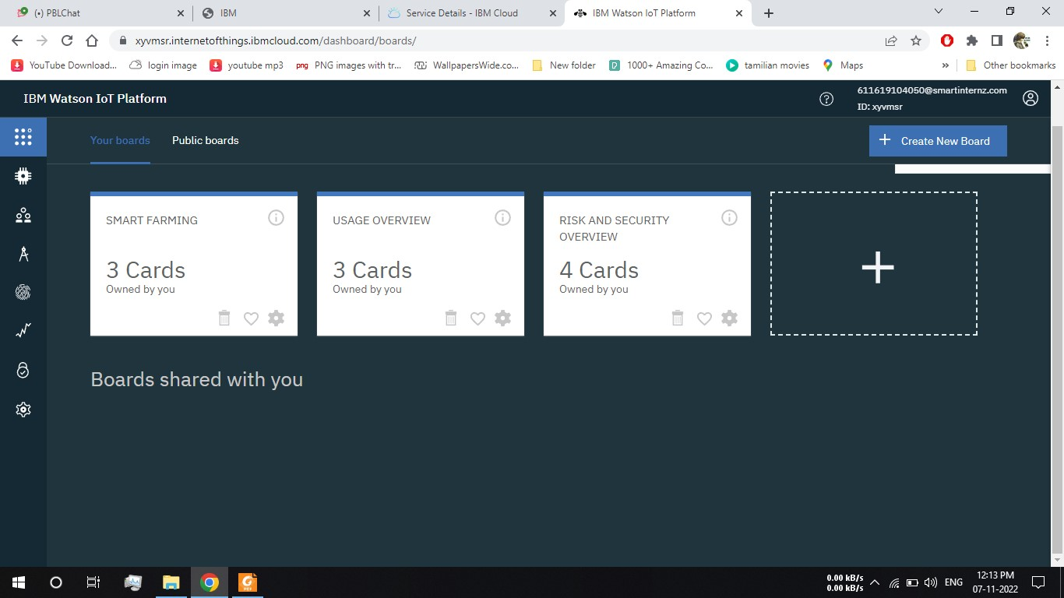

Step 8: after clicking create a new device / add device you can choose an device type and device id and complete the following information to create a device

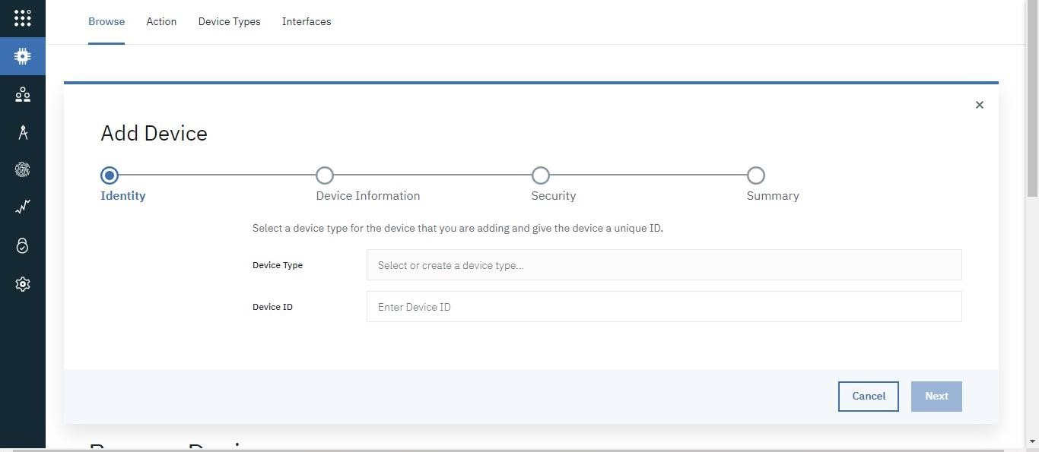

Step 9: created a device of NodeMCU

